Theorem 1.1: The sum of the first n positive integers is:

Basis:

Induction Step 1: Assume True

Induction Step 2: Show True

Theorem 1.2: If x is any real number other than 1, then

Remark:

Basis:

Induction Step 1: Assume True

Induction Step 2: Show True

Ex 1:

Prove:

For , let P(n) be the statement:

for

Basis:

Induction Step 1: Assume True

Induction Step 2: Show True

Ex 2:

Prove:

sum of cubes of first n natural numbers is:

for

Basis:

Induction Step 1: Assume True

Induction Step 2: Show True

Ex 3:

Prove:

Basis:

)

Induction Step:

From Where:

Therefore

Ex 4:

Prove:

Basis:

LHS = (1)(2) =2

Induction Step 1: Assume True

Induction Step 2: Show True

Therefore

Ex 5:

Prove:

Basis:

LHS = 1

Induction Step 1: Assume True

Induction Step 2: Show True

The result is true

Ex 6:

Prove:

Basis:

LHS =

RHS =

Hence , LHS =RHS

RHS =

LHS =

LHS = RHS

Ex 7: Fibonacci numbers

Prove:

Basis:

LHS

RHS

LHS

RHS

Ex 8: Fibonacci numbers

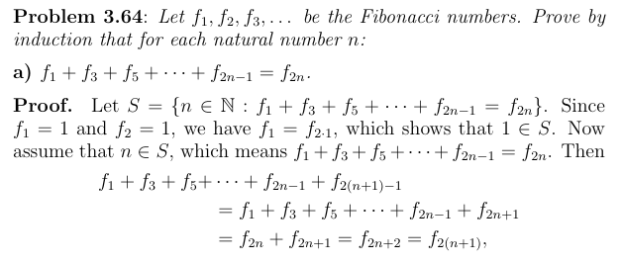

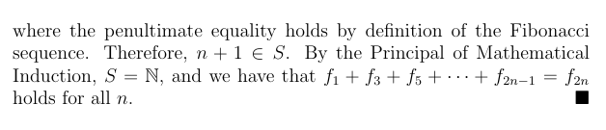

Ex 9: Fibonacci numbers

